Final Project: Pick a Project
Computer Science - Week 10
Oct 3, 2026 - Version 0.0.2
Please make sure to your UD email AND name is below. Unless your UD emails are included in this table, then you will not earn any points for this assignment when it is graded! Every person should submit their own individual worksheet.

Talk about each of the questions with a friend or our LLM (or both), but make sure the words you enter below are yours (with the obvious exceptions notwithstanding). Brainstorming is best done in full sentences, and the main goal here is brainstorming. It's worth reviewing the information in this series of pages in the Drafter documentation to gain a better understanding of the process.

Role | Name | Email
Developer (You) | Paul Sanchez | paulsanc@udel.edu
Friend (optional)

Part 1: The Goal & Prior Implementations
- Identify the Goal: What specific goal are you trying to address? Think about your passions, hobbies, and academic interests. The latter are an excellent candidate to focus on. Some majors have suggestions listed below: these were provided by faculty in those departments. Other majors could consider a focus tied to a big final assignment in one of their recent courses in their major.
  - Biomedical Engineering majors may consider one of the following:
    - If you have started (or completed) the Cell/Tissue Design final project in BMEG100, design an organoid, which involves combining a cell type, biomaterial, and testing method. Have the website include a description and diagram of your design concept, a testing method, a needs statement, and an impact statement relevant to their organoid. Also include a link to a paper that supports your idea and a paragraph describing how that paper supports your design concept.
    - Otherwise, create a website related to your BMEG100 Lab Report 1, Cytoskeletal and Nuclear Staining Lab Report Guidelines, linked here (University of Delaware account required to access).
  - Chemistry and Chemical Engineering majors may consider creating an automated chemistry assistant that takes balanced reaction equations, starting reactant masses, and a harvested product amount to determine the limiting reactant, theoretical yield, and percent yield based on principles from Chemistry 2e (OpenStax) — Chapter 4: Chemical Reactions and Stoichiometry. To avoid manually compiling atomic mass tables or writing custom string tokenizers, use the ChemPy library to parse molecular formulas into exact molecular weights and verify reaction stoichiometry against compound data from the NIH PubChem Database. The program outputs an organized breakdown of limiting reagent status, product yields, and remaining masses of unreacted species. Also use the heat of the reaction to determine if it is exothermic or endothermic, and compute the heat flow per mole of the product.
  - Majors in the Electric & Computer Engineering department may consider a steganography project that hides messages in images, and then retrieves those messages from uploaded images.
  - Mechanical Engineering majors may consider a project that somehow uses both the NumPy and SciPy Python libraries.
I would like to create a calculator for numerous ‘lower level’ calculus problems that utilizes algorithms.

- Prior Implementations: Search the internet. What existing tools or websites currently attempt to address it?
Numerous websites and apps like symbolab, gauth, mathway, and wolfram alpha already do this, but seem to use AI instead of algorithms

- Your Implementation: Briefly describe the legitimate purpose or functionality of your site. How would you want this web application to be used?
Users would go to each page with a certain type/syntax of problem they want to solve

Part 2: The Input-Process-Output (IPO) Model
Think about the fundamental flow of your program.
- The Core Goal: Every program has three main phases: taking input, processing data, and presenting output. In one sentence, what is the ultimate goal your program will accomplish for the user? Be specific and use CS1 concepts.
The program will solve calculus problems like derivatives and integrals using inputs for specific terms from the user and output solutions

- Input: What specific information will the user need to provide to your program? (e.g., a city name, a numerical budget, a list of hobbies).
Terms in their function, the function itself, what type of problem it is, etc

- Processing: At a high level, how will the computer manipulate or evaluate that data? (e.g., calculate the average, filter out options that are too expensive, compare the input against a database).
The program will put the inputs through an algorithm already made to solve those specific problems, like derivatives and integrals

- Output: What will the user get back? (e.g., a recommendation, a calculated safety factor, a formatted schedule).
The solution to a problem, which may come in the form of ‘solved for x’ or limits, etc

Part 3: Data Abstraction
Identify the "nouns" of your problem.
- Representing Reality: Abstraction is the process of representing the real world inside a computer by ignoring unnecessary details. What are the core "things" (nouns) your program needs to track? (e.g., If building a recipe app, the nouns are "Recipe" and "Ingredient").
Terms, Problem Type, Current problem

- Identifying Properties: For the most important "thing" you listed above, what 3 to 4 specific details do you actually need to solve your problem, and what details will you abstract away?
  - Details I need: (e.g., Ingredient name, weight, cost)
  - Details I will ignore: (e.g., Ingredient color, brand, expiration date)
Problems can be more complex, and the following could use to describe it as a dataclass:
problem id (the unique identifier for a problem)
problem type, as a str
expression, the problem itself (as a str)
answer: as a str, ties an answer to the problem itself so potentially the program wouldn’t need to recompute

Part 4: Challenges, AI Strategy, & Goals
- Difficulties: What parts of this project seem the most difficult or technically complex?
Using arbitrary symbolic calculus without importing any libraries will make it difficult to process math, especially only using python’s default built-in mathematics

- Coding Strategy: If you will be using an LLM to help code, how will you ensure you understand the generated code and avoid "hallucinations" or "shallow learning" (copying without understanding)? If you won't be using an LLM to help code, this project might take about 4 hours a week to complete, so list each of the days and times in which you work on the project.
All code will be reviewed manually for any mistakes , as well as evaluating the LLM’s decisionmaking process and planning for any inconsistencies before changes are made

- Goals: What is your ultimate goal for this project? (e.g., Impress the graders with a creative UI, build something I can use in my other classes, learn Drafter deeply).
Make no mistake i am great at CSIC106, but I struggle constantly with attention to the point of having only one hour of free time daily (i am seeking an ADHD evaluation), so I’d like to learn how to use LLMs to save time

Part 5: Research & Brainstorming Conversation
Have a conversation with a Generative AI tool (like ChatGPT or Claude) OR a friend about your project idea. Do not ask for code. Instead, use the AI/friend as a sounding board to research your problem.
- The Initial Prompt/Question: Ask the AI or your friend to help you brainstorm. (e.g., "I want to build a simple web tool to help students track their study hours. What are 3 common problems students face when tracking their time, and what are 3 simple features a basic tool should have?"). Paste your prompt below:
Here is a coding project's requirements
- At least 7 routes.
- At least 5 pages.
- The implementation of the State dataclass must have at least 4 fields.
  - At least one field must be a list of class instances or a dictionary of class instances.
    - This means that there must be a second dataclass.
  - At least 4 state fields, including the list or dictionary of class instances, must each be meaningfully modified in at least one route; those 4 state fields cannot be constants.
- At least 3 input fields (TextBox, CheckBox, SelectBox, TextArea). They don't have to be the same type.
- At least 3 meaningful if statements.
- At least 1 loop that iterates over an attribute of the list of class instances or dictionary of class instances in a meaningful way.
- The site should have a legitimate purpose or functionality.
- No global variables (global constantsLinks to an external site. are fine).
- You must use the Drafter library.
- Any advanced coding techniques (i.e. that weren't covered in this course) used are thoroughly documented in the code.
With python, I plan on vibe coding a website to solve common calculus problems, such as derivatives, integrals, and limits, using already created algorithms and predefined problems
How feasable is this?

- The Response: Briefly summarize the best ideas the AI or your friend suggested. What existing solutions or prior apps did they mention?
The AI is very supportive of my idea, and gave many design options and ideas for me to take up, like what to design the application around specifically, how to meet requirements, etc. The AI did not mention any existing solutions, other than if you mean solutions for me to implement as a prgoram, which dictates different approaches like using predefined problems and solution templates, versus a full ‘symbolic calculus engine’

- The Pushback: You must reply to the AI/friend to narrow the scope when it's over-ambitious. Pick the most complex feature they suggested and explain why it is too complicated for an introductory programming project. Ask them for a simpler alternative. Paste your response here:
(LLM already answered this in their first response)
The LLM suggested that i used predefined problems and solution templates, only allowing users to input specific problem types to get accurate solutions, which would be simpler and would work with python without any additional libraries
This is in contrast to using a ‘full symbolic calculus engine’ which would not only be complicated code and logic wise, but would also have “availability, loading, and compatibility issues”

- Reflection: Based on this conversation, how has your project idea changed or become more focused?
I feel especially after the specific ideas and suggestions the LLM showed me, i feel much more confident in my project

Part 6: Resource Planning
- What resources will you use if you get stuck?
I plan on utilizing python & individual library documentation, as well as LLMs.

- If your LLM provides code that causes a Drafter or Bakery error, or if you run into a problem during deployment, what is your step-by-step debugging plan to resolve it?
- View the error
- Find the line of code causing the error
- Consider the logic behind the code
- Make changes
- Test the line of code
- Consult python documentation or an LLM if ecessary

Part 7: LLM Conversation
If you used an LLM in any part of this work, copy and paste every part of that conversation below. Otherwise, you may be given a zero for the assignment. Obviously, these words will not all be yours, and this is the exception to the requirement at the top of this assignment that all responses be in your own words. If you did not use an LLM to assist you in this assignment, simply say so below.
Here is a coding project's requirements
- At least 7 routes.
- At least 5 pages.
- The implementation of the State dataclass must have at least 4 fields.
  - At least one field must be a list of class instances or a dictionary of class instances.
    - This means that there must be a second dataclass.
  - At least 4 state fields, including the list or dictionary of class instances, must each be meaningfully modified in at least one route; those 4 state fields cannot be constants.
- At least 3 input fields (TextBox, CheckBox, SelectBox, TextArea). They don't have to be the same type.
- At least 3 meaningful if statements.
- At least 1 loop that iterates over an attribute of the list of class instances or dictionary of class instances in a meaningful way.
- The site should have a legitimate purpose or functionality.
- No global variables (global constantsLinks to an external site. are fine).
- You must use the Drafter library.
- Any advanced coding techniques (i.e. that weren't covered in this course) used are thoroughly documented in the code.
With python, I plan on vibe coding a website to solve common calculus problems, such as derivatives, integrals, and limits, using already created algorithms and predefined problems
How feasable is this?

How feasible is your calculus solver project?
I think this is a very feasible project, and it has the potential to be an excellent CS1 final project. The idea is useful, has a clear purpose, and naturally fits many of the requirements you listed.
The biggest challenge is not building the website itself. It's deciding how much calculus your application should solve.
A website that solves every possible derivative, integral, and limit would be extremely difficult to build from scratch. But a website that solves a curated collection of common calculus problems, explains the steps, and lets users practice is very achievable with Drafter and AI assistance.
I'd recommend building a Calculus Problem Solver & Practice Tool rather than trying to recreate WolframAlpha.

1. Feasibility breakdown
Feature | Feasibility | Notes
Derivative calculator | High | Support common polynomial, trigonometric, and exponential functions.
Integral calculator | Medium | Start with basic indefinite and definite integrals.
Limit calculator | High | Support common limits using predefined rules and patterns.
Step-by-step solutions | High | Store explanations alongside known problems or generate them from templates.
Predefined problem database | Very high | A Python list of dataclass instances is a natural fit.
User practice mode | Very high | Use Drafter routes, state, and input components.
Graphing functions | High | Drafter supports graphing with matplotlib.
Arbitrary symbolic calculus | Low to medium | This is the hardest part, especially for an introductory student.
Drafter is designed for interactive Python applications with routes, dataclasses, lists, and browser-based functionality. It runs on the frontend, which is an important consideration for your project.
Drafter
The main limitation is that you don't have a backend or database. That isn't a problem for this particular idea: you can store your predefined problems directly in Python, and users can use the calculator entirely in their browser.

2. How I would design the application
I would organize the site around three main features:
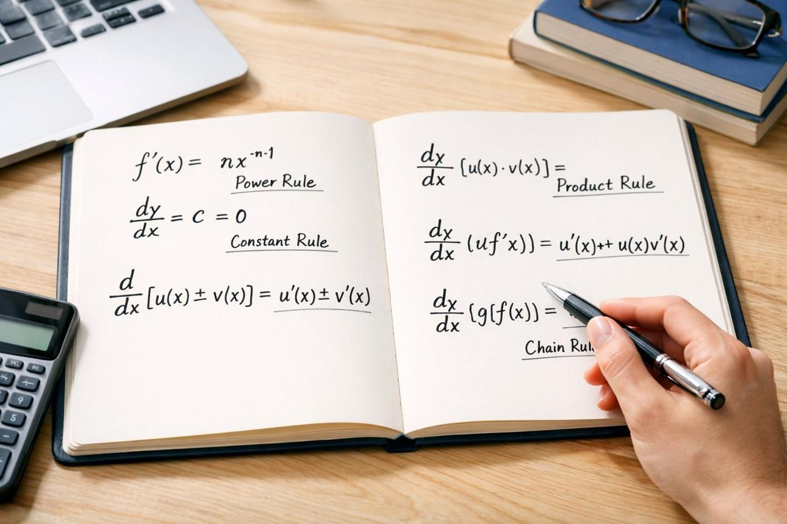
Derivative Solver
Users select or enter a function and get its derivative, a step-by-step explanation, and optionally a graph.
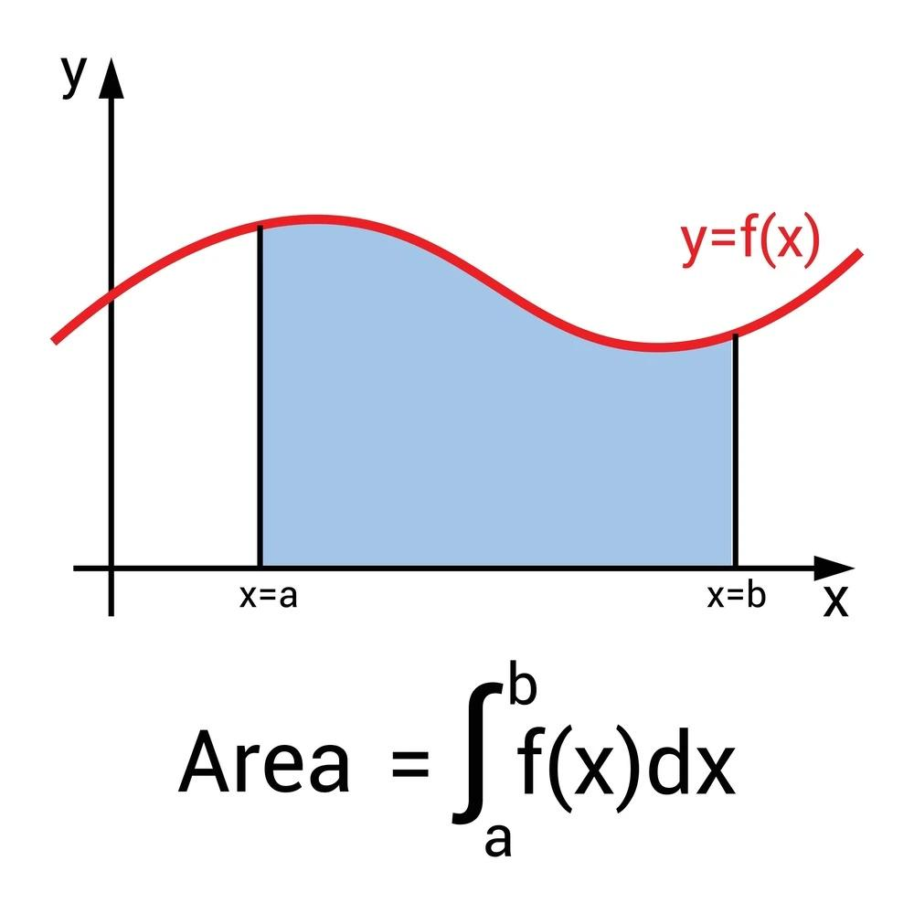
Integral Solver
Users solve basic indefinite or definite integrals and learn about the power rule, substitution, and area under a curve.
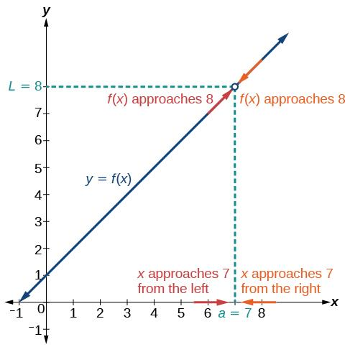
Limit Solver
Users evaluate common limits, including direct substitution, factoring, and limits involving infinity.
I would also include a practice section where users answer predefined calculus questions and receive feedback.
This gives the application a legitimate educational purpose: helping students understand calculus procedures, not just obtain answers.

3. How to meet your 10 requirements
This is the part I would plan carefully before vibe coding.

Requirement 1 & 2: At least 7 routes and 5 pages
You can satisfy both requirements with 7 distinct routes.
Here is one possible structure:
Route | Page | Purpose
/ | Home | Introduction and navigation
/derivatives | Derivatives | Derivative calculator
/integrals | Integrals | Integral calculator
/limits | Limits | Limit calculator
/practice | Practice | Random calculus problems
/problem-bank | Problem Bank | Browse predefined problems
/history | History | Review previously solved problems
These are all reasonable pages for the application.
One thing to remember: a route should represent a meaningful page or destination. Don't create seven routes that all lead to essentially the same page just to satisfy the requirement.

Requirement 3: State dataclass with 4 fields
This is where your application can naturally satisfy the rubric.
I would use two dataclasses:
- CalculusProblem: Represents a predefined calculus problem.
- State: Stores the application's current information.
For example:
@dataclass
class CalculusProblem:
problem_id: int
problem_type: str
expression: str
answer: str
explanation: str
And:
@dataclass
class State:
problems: list[CalculusProblem]
current_problem: CalculusProblem
user_answer: str
feedback: str
solved_count: int
This gives you five fields in State, including a list of class instances.
The important part is that the fields are meaningfully modified in your routes.
For example:
State field | Route that modifies it
problems | Problem Bank: add a new problem or update a problem
current_problem | Practice: select a different problem
user_answer | Solver: store the user's submitted answer
feedback | Solver: display correct or incorrect feedback
solved_count | Practice: increment after a correct answer
You don't need all five fields to be modified, but at least four must be meaningfully modified, including the list of class instances.
Important: Don't just create a list of problems and leave it unchanged. Your rubric explicitly requires the list or dictionary of instances to be meaningfully modified.
A simple way to do this is to let users add custom problems to the problem bank.

Requirement 4: At least 3 input fields
This is easy to accomplish.
For example:
- TextBox: Enter a calculus expression.
- SelectBox: Choose derivative, integral, or limit.
- TextBox: Enter an answer.
- CheckBox: Show steps automatically.
- SelectBox: Choose a difficulty level.
You only need three, but these inputs fit the application's purpose.

Requirement 5: At least 3 meaningful if statements
Your application will naturally need conditional logic.
Examples:
if user_answer == current_problem.answer:
state.feedback = "Correct!"
if problem.problem_type == "derivative":
# Show derivative-specific explanation
if state.solved_count >= 10:
# Display a completion message
These are meaningful conditions, not artificial ones added to meet a rubric.

Requirement 6: A meaningful loop
You could iterate through the problem bank to display problems matching the user's selected topic.
For example:
for problem in state.problems:
if problem.problem_type == selected_type:
# Display the problem
This is a particularly good fit because the loop operates directly on your list of class instances.

Requirements 7–10
Requirement | How your project satisfies it
Legitimate purpose | Educational calculus assistance
No global variables | Store changing information in State; immutable constants are fine
Use Drafter | Build the entire frontend using Drafter
Document advanced techniques | Explain any unfamiliar libraries, algorithms, or symbolic processing

4. The biggest technical challenge: solving arbitrary calculus problems
This is the area where I would be most cautious.
There are three possible approaches.
Recommended
Approach A: Predefined problems and solution templates
You store problems in a list of dataclass instances, with answers and explanations.
For example:
Problem: Find the derivative of x³.
The derivative answer is 3x². Your application can explain that the power rule multiplies by the original exponent and reduces the exponent by one.
This is the most predictable and manageable approach.
Possible extension
Approach B: Pattern matching
You allow users to enter expressions, then recognize supported patterns.
For example:
- x^2 → derivative 2x
- x^3 → derivative 3x^2
- sin(x) → derivative cos(x)
This is more flexible, but requires parsing mathematical expressions and handling edge cases.
I would add this only after the predefined problem version works.
Higher risk
Approach C: A full symbolic calculus engine
A library such as SymPy can perform symbolic differentiation, integration, and limit calculations.
However, integrating a symbolic math library into a browser-based Pyodide application may involve package availability, loading, and compatibility issues.
I would not make this the core requirement of the project unless you have tested it in your actual Drafter environment.
One important distinction: using an existing algorithm or library is not necessarily a problem. Your assignment explicitly allows AI assistance and predefined algorithms. But you should be able to explain what the algorithm does, and you should thoroughly document advanced techniques.

5. What I would actually build
I would make the project a Calculus Study Assistant with the following scope.

Core functionality
- 20–30 predefined problems.
- Derivative, integral, and limit categories.
- A calculator interface with a topic selector.
- Step-by-step explanations.
- A practice mode with answer checking.
- A problem bank users can browse.
- A graphing feature for supported functions.
- A history page that remembers problems solved during the session.

Example problem bank
Here is a sample of how your predefined problems could be organized.
Topic | Example problem | Answer
Derivative | f(x)=x3f(x)=x3 | 3x23x2
Derivative | f(x)=sin⁡(x)f(x)=sin(x) | cos⁡(x)cos(x)
Integral | ∫x2 dx∫x2dx | x33+C3x3​+C
Integral | ∫2x dx∫2xdx | x2+Cx2+C
Limit | lim⁡x→2x2limx→2​x2 | 44
Limit | lim⁡x→3(x+1)limx→3​(x+1) | 44
For the practice mode, you can randomly select a problem from your predefined collection, ask the user to solve it, and provide feedback.
You can also make the application more interesting by adding a difficulty selector:
- Easy: Basic power rule.
- Medium: Product rule or factoring.
- Hard: Chain rule or more complicated limits.
That creates a useful application without requiring a full symbolic math engine.

6. My recommendation for your project pitch
Since your uploaded assignment includes a project pitch and planning worksheet, I would make sure the scope is clearly defined before you start generating code.
CS1 Final Project Alpha F26.pdf
Here is how I would frame the project:
Project Title: Calculus Study Assistant
Project Description:
I plan to develop an interactive calculus study website using the Drafter Python library. The website will help students practice and understand common calculus problems involving derivatives, integrals, and limits.
Users will be able to select a calculus topic, browse predefined problems, submit answers, and receive feedback along with step-by-step explanations. The application will also include a practice mode that allows students to solve randomly selected problems and track their progress.
The website will use Python dataclasses to represent calculus problems and application state. A predefined problem bank will store supported expressions, answers, and explanations. The application will focus on common calculus techniques rather than attempting to solve every possible symbolic mathematics problem.
The ultimate goal is to create a useful educational tool that helps students learn calculus procedures and practice solving problems independently.

Final verdict
I would rate this project:
- Idea quality: 9/10
- Fit for the rubric: 9/10
- Feasibility with AI assistance: 8/10
- Feasibility if you attempt arbitrary symbolic calculus: 4/10
The project has a good balance of functionality, educational value, and technical depth.
My strongest recommendation is to build the predefined problem solver first, then add more advanced input handling only if you have time.
You can satisfy every requirement without creating a full symbolic calculus engine. The more ambitious version is a great extension, but the predefined problem bank and step-by-step explanation system should be the foundation.
Would this be easier with other python libraries? What would change?
Yes! And for your particular project, using a different Python library could make the actual calculus calculations significantly easier.
However, there's an important distinction:
- A different library could make the math easier.
- A different web framework could make the website easier to build.
- A different framework might make it harder to satisfy your Drafter-specific assignment requirements.
Since this is a CS1 final project, I would separate those decisions.

1. Which Python libraries would help?
Here are the main options I would consider.
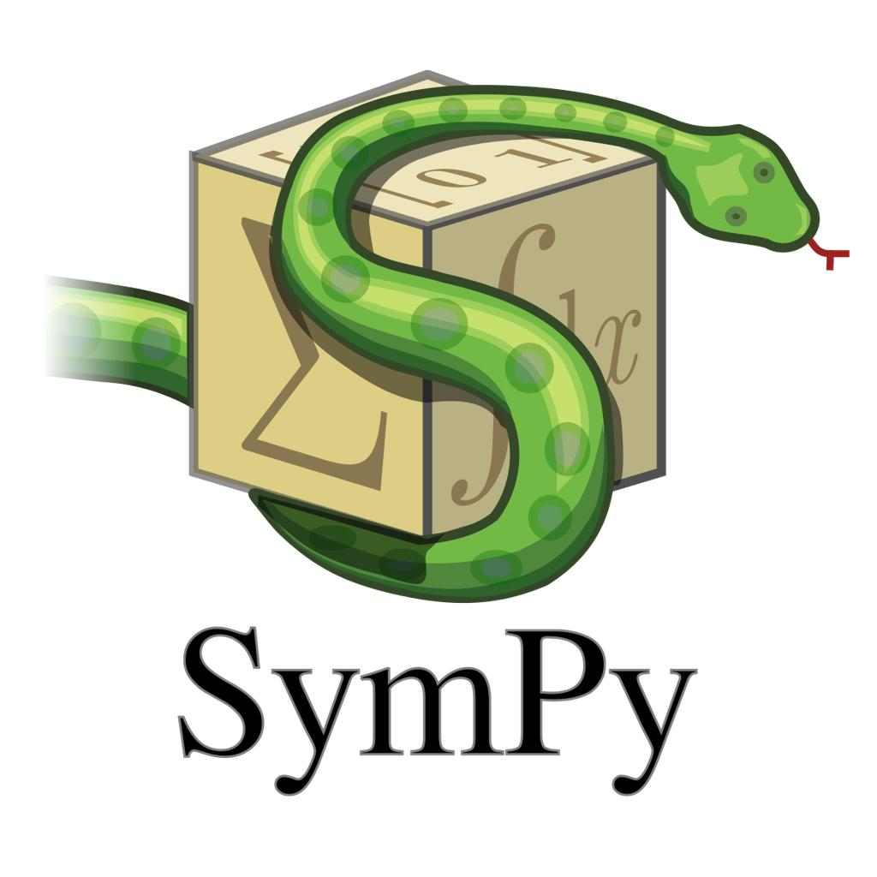

SymPy
Best for calculus
A symbolic mathematics library that can calculate derivatives, integrals, and limits automatically.
What changes: Instead of manually coding calculus rules, you can call existing functions to solve expressions.


Streamlit
Best for quick web apps
A Python framework for creating interactive websites with relatively little code.
What changes: You could create a calculator interface with text inputs, buttons, and output without building routes and components manually.


Flask
Best for traditional web development
A lightweight Python web framework that uses routes and templates.
What changes: You would have more control over the website, but you'd also need to handle HTML templates, server-side processing, and possibly a database.
My recommendation: SymPy is the library that would make the biggest difference to your calculus solver.
Streamlit and Flask are alternatives to Drafter, not replacements for SymPy.

2. How SymPy would change your project
Without SymPy, you might create a predefined problem bank:
@dataclass
class CalculusProblem:
expression: str
answer: str
explanation: str
Then manually store problems such as:
CalculusProblem(
expression="x^3",
answer="3x^2",
explanation="Use the power rule."
)
This works, but you have to manually define every supported problem and answer.
With SymPy, you could potentially accept a much wider range of expressions.
For example:
import sympy as sp

x = sp.Symbol("x")

function = x**3 + 2*x**2 + 5*x

derivative = sp.diff(function, x)

print(derivative)
Output:
3*x**2 + 4*x + 5
The function sp.diff() calculates the derivative.
You could also calculate integrals:
integral = sp.integrate(x**2, x)

print(integral)
Output:
x**3/3
And limits:
limit = sp.limit(
(x**2 - 4)/(x - 2),
x,
2
)

print(limit)
Output:
4
This means your website could support expressions that you didn't manually program into your problem bank.

What would your application architecture look like?
User Input
Enter an expression, select a calculus operation
Drafter Frontend
Collect input and manage application state
SymPy Calculation Engine
Calculate derivatives, integrals, and limits
Formatted Output
Display answers, explanations, and graphs
This is a clean architecture because each part has a specific job.
Drafter manages the website, while SymPy manages the mathematics.

3. The important catch: SymPy and Drafter
This is the part you should investigate before committing to the project.
Your assignment requires Drafter, and Drafter runs Python in the browser using Pyodide.
SymPy is a relatively large library. You cannot automatically assume that importing it will work in your Drafter application.
There are two possible approaches:
Approach | How it works | Difficulty
SymPy inside Drafter | Run symbolic calculations directly in the browser | Depends on Pyodide compatibility and package loading
SymPy on a Python backend | Send expressions to a server running SymPy | Easier to use SymPy conventionally, but adds a backend
The second approach is common in web development, but it conflicts with your project's stated architecture: Drafter has no backend or database.
I would not introduce a backend unless your instructor explicitly permits it.

My suggestion
Before you build the entire application, create a tiny Drafter test that imports SymPy and calculates one derivative.
If that works in your actual environment, great! You can build around it.
If it doesn't, you still have your predefined problem bank as a fallback.

4. Would Streamlit make the project easier?
If your assignment did not require Drafter, Streamlit would be an interesting alternative.
For example, a basic calculus calculator could look something like this:
import streamlit as st
import sympy as sp

x = sp.Symbol("x")

st.title("Calculus Solver")

expression = st.text_input(
"Enter a function",
"x**2"
)

operation = st.selectbox(
"Choose an operation",
["Derivative", "Integral", "Limit"]
)

if st.button("Calculate"):
function = sp.sympify(expression)

if operation == "Derivative":
result = sp.diff(function, x)

elif operation == "Integral":
result = sp.integrate(function, x)

elif operation == "Limit":
result = sp.limit(function, x, 0)

st.write(result)
This is a rough example of the interface logic, not a complete application.
It illustrates how quickly you could create a calculator when the web framework and math library handle much of the infrastructure.
However, Streamlit does not satisfy the requirement to use Drafter.
You would also need to deliberately implement your dataclasses, state modifications, and routes to meet the rubric. Some of those requirements would be less natural in Streamlit.

5. What I would personally choose for your project
Here's my ranking:
Option | My recommendation
Drafter + predefined calculus algorithms | Safest option for the assignment
Drafter + SymPy | Best if SymPy works in your Pyodide environment
Streamlit + SymPy | Best for quickly building a standalone calculus solver, but not for your current rubric
Flask + SymPy | More flexibility, but significantly more infrastructure
I would choose Drafter + SymPy if compatibility is confirmed.
It gives you the most impressive version of the project while keeping the core application relatively manageable.
If SymPy does not work, I would use a curated problem bank and implement a few common calculus rules manually.
One more thing: SymPy can calculate the answer, but it doesn't automatically give you the kind of student-friendly step-by-step explanation you probably want. You would still need to build an explanation system, perhaps by associating each problem or supported rule with a sequence of explanatory steps.
That is actually a good CS1 project feature because it gives you something meaningful to build beyond simply calling a library.

Part 8: Submit
In Google docs, with this document open, please click on File > Download > Microsoft Word (.docx), and make sure you put that download somewhere you can find it again. Then, upload it to the Canvas assignment about selecting or brainstorming your final project.

When you're done with this assignment, review this page of the Drafter documentation to better prepare for the next step.

